
SELLINDGE VILLAGE NEWS

NOVEMBER 2025 Edition 739
HI KENT Reg Charity 1052036 www.hikent.org.uk
The local charity for people with a hearing loss. Hi Kent provides FREE NHS hearing aid aftercare, advice and battery supply. The local hearing aid maintenance clinic will be in Coffee & Company in the Main Hall, Sellindge Village Hall on – November 11th from 10.15am to 11.15am.
Hi Kent at Coffee & Company every 2nd Tuesday Other 2025 dates –– Dec 9th


SHEPWAY VOICES – MASC

Introduction – Shepway Voices is a community choir operated by MASC, Music and Arts for the Shepway Community, (MASC) which is a registered charity with the charity number 1170602, dedicated to bringing music and the arts to everyone in the Shepway area.

MASC provides free music and arts projects to children and young people, aiming to remove social, financial, and physical barriers to participation. The organization runs several choirs, including Shepway Primary Singers for primary school children, Shepway Youth Voices for secondary school age, and Shepway Voices for adults, all of which are free and open to anyone regardless of ability.

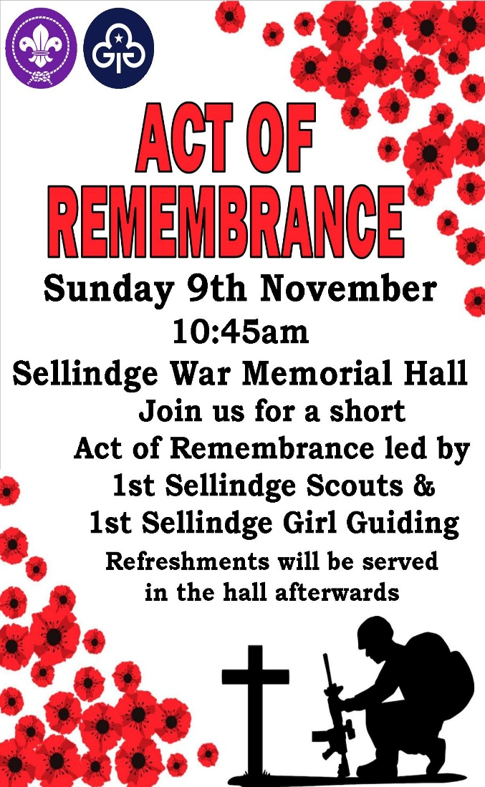
Our Event – On 29 November, at The Holy Trinity Church In Folkestone, Shepway Voices (Adult Choir) will be performing our Christmas Concert, with all proceeds going to The MASC Charity. It would be wonderful if you could include our flyer, attached, into your newsletter, as I hope this will be an event your readers would be pleased to hear about. It would be lovely if some of your readers joined us for the evening an especially so if this lead to some joining our choir as a result of hearing us sing.


It will be a joyous celebratory occasion and one we all look forward to
See page 5 for more information

SELLINDGE PARISH COUNCIL
www.sellindge-pc.gov.uk 01303 813 271 clerk@sellindge-pc.gov.uk

The next meeting of your Parish Council on Tuesday November 11th starting at 6.30pm in the Durling Hall.
Dog Poo Bags – Dog poo bags are still available from the Parish Council Office on Tuesday mornings or Friday afternoon. Dog poo bags are also still available from Nigel at Trust Cottages in Moorstock Lane, he puts them on a patio chair or table outside his house.
Also now available from the Dog Poo Bag dispenser which is located at the entrance to the Village Green.
Parish Councillor Vacancy – There have been no requests for an election to fill the recently advertised vacancy. So, if you would like to become a Parish Councillor. Please contact the Proper Officer / Clerk for more details – clerk@sellindge-pc.gov.uk phone 01303 813271 (please leave a message)
Come to the office when it is open (Tues morning & Fri afternoon) or phone to arrange an appointment.

MOBILE LIBRARIES DATES and TIMES FOR NOVEMBER 2025
www.kent.gov.uk/leisure-and-community/libraries/visiting-a-library/mobile-libraries

Email ashfordlibrary@kent.gov.uk Tel 03000 41 31 31

Lay By on A20 at the bottom of Swan Lane.
Thursdays – 9.15am to 9.45am on November 6th & 20th

St Kathrines Cresent TN25 6FU.
Fridays – 2.50pm to 3.50pm on. November 7th & 21st



KCC CLLR Christopher Hespe – (Reform UK) – Elham Valley – christopher.hespe@kent.gov.uk

KCC – Summary of Opposition Activity: Kent County Council (1 August – 30 September 2025)
This report summarises the work of the Opposition within Kent County Council over August and September 2025. During this period, Opposition Members were actively involved in all Cabinet Committee meetings, focusing on key issues such as financial oversight, the need for increased investment in social care and local infrastructure, and promoting transparency in departmental spending. They also scrutinised progress on the Special Educational Needs and Disabilities (SEND) improvement plan, advocating for more resources for schools, and challenged the administration on active travel schemes and rural bus service support.

In Scrutiny Committee meetings, the Opposition prioritised detailed monitoring of council performance, with special attention given to budget adherence, highways maintenance, and adult social care waiting times. They examined the new framework contract for Nursing and Residential Care, and initiated a series of meetings to address ongoing issues related to SEND, considering resources, finance, and the impact on pupils and families.

At the Full Council meeting in September, the Opposition successfully negotiated a motion for stronger leadership on vaccination programmes and opposed the rescinding of the council's recognition of the climate emergency. They also provided detailed feedback on the new strategic statement. The Opposition remains committed to transparent scrutiny and welcomes parish feedback to ensure local concerns are addressed.

F&HDC NORTH DOWNS WEST WARD – Cllr Jenny Hollingsbee: (Conservative Party)
Jenny.hollingsbee@folkestone-hythe.gov.uk Mobile 07887 918 458

Otterpool Park – At the full Council Meeting on 1 October 2025, I put two questions to the Leader of the Council – (1) The 3 month extension to the collaboration agreement with Homes England with Otterpool Park comes to an end shortly. If there is no commitment or funding from Homes England at the end of this agreement, what is plan B? (2) As the Otterpool Park team has been reduced to 5, and negotiations with Homes England are with the Leader and Chief Executive, what is the role of the Otterpool Park Board ?
See the answers to these questions on FHDC website under Democracy Cllr Questions and answers - Minutes.pdf

Design Code - A survey to provide input and feedback on the design and character of local development has been launched to help identify clear principles for what is built in east Kent. A design code is a planning document that sets out specific requirements for new development, it could include layout, (including street pattern), how landscaping should be approached, including the importance of streets being tree-lined, height of buildings and façade material, environmental performance of places and building, local vernacular and heritage, architecture and materials.
Residents can have their say by completing the survey on the website before midnight on Sunday 9 November 2025.

St Eanswythe - A sculpture depicting St Eanswythe – the patron saint of Folkestone – has been restored. The statue, which sits proudly near the entrance to Radnor Park, was damaged by vandals June last year.
A replacement head was carved using a mould retained by the original artist. Unavoidable delays meant this took longer than expected. Saint Eanswythe was the granddaughter of King Ethelbert and Queen Bertha.
It is believed she founded Folkestone Priory – one of the first Christian communities for women in Britain – around the middle of the 7th century, having chosen the town as her retreat.

Local Government Reorganisation – the District Council will have to choose which model to put forward to Kent Leaders from a single unitary, a three unitary solution, two four unitary arrangements and a five unitary arrangement. The Local Government Reorganisation working group will be meeting on the17th October. The Leader will be presenting detailed information to all Councillors on 12th November and a decision will be made at an extraordinary meeting of the Council to be held on the 19th November, which then has to be ratified by the Cabinet. There is still time to comment on these models, I am happy to pass on views to the Leader.

Ward Grants – I have supported Lyminge Primary School Stage Stars with £250 for purchase of microphones, £250 to Postling Village Hall to support the installation of solar panels made possible by the Rural Prosperity Grant and the Monks Horton Community £500 for cushion pews and a mobile sink unit.

NORTH DOWNS WEST WARD – Cllr Elaine Martin Contact: (Green Party) Elaine.Martin@folkestone-hythe.gov.uk

The Government is going ahead with its Local Government Reorganisation plans. Leaders of councils in Kent and Medway have asked advisors KPMG to look in more detail at two options for unitary councils and the areas they should cover. KPMG’s work is being paid for from central government money set aside to deliver local government reorganisation in Kent and Medway. Some councils are funding their own business plans for three alternative options. F&HDC councillors will meet on 19 November to discuss the options, and a preferred option will then be agreed ready for submission to Government by 28 November. The final decision will be made during summer 2026.

There is an invitation to become a member of a new community panel helping to shape a new design code for the district. The code sets out specific requirements for new development, and the council wants it to reflect local knowledge about character and preferences e.g. street design, building materials, parking and bin storage. If you are interested in joining please complete a brief online application form or email planning.policy@folkestone-hythe.gov.uk for more information. You will be invited to attend an in-person workshop in Folkestone in the afternoon of Saturday 29 November 2025.

The Green Grant Scheme has been an overwhelming success and has awarded more than 30 grants to community groups, parish councils and schools funding to support sustainability and carbon reduction projects across the district several of which were awarded in North Downs West.
The scheme is closed for this year but will be launched again in the next financial year.

The Rural England Prosperity Fund is also open again and available for applications by Community Organisations. See The Folkestone Works website for details.

Charges in Folkestone & Hythe District Council car parks and on-street pay and display bays are once again being waived on the three Saturdays leading up to Christmas Day to help support the local economy. The dates that this applies are Saturday 6 December, Saturday 13 December and Saturday 20 December.

SPEEDWATCH -🚦 Volunteers Needed – Join Community Speedwatch! 🚦
Do you care about road safety in our area? Would you like to help reduce speeding and make our roads and streets safer for everyone?

We’re looking for volunteers to join our Community Speedwatch team. Speedwatch is a local initiative where trained residents work together, with support from the police, to monitor vehicle speeds and raise awareness about the dangers of speeding.
✅ Full training is provided
✅ Flexible volunteering – even a small amount of time helps
✅ A chance to make a real difference in keeping our community safe
If you’d like to get involved or find out more, please contact:
📧 admin@sellindge-pc.gov.uk
📞 01303813271 Together, we can slow down speeding and keep our roads safer for all.

SELLINDGE WALKING GROUP
– Please note new meet up time and set off time.

We meet at the Village Hall on a Tuesday morning at approximately 10am and set off at 10.15am.
We walk 1 and 1/2 hours around the village using local footpaths.
This does involve crossing fields and climbing over stiles, so appropriate footwear is advisable.
We are no longer part of the NHS Walking for Health Scheme just a group of locals who enjoy walking.
Everyone walks at their own risk.

THE SELLINDGE SPORTS & SOCIAL CLUB – www.sellindgesportsclub.co.uk

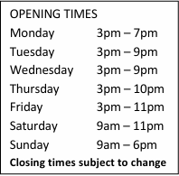
Saturdays and Sundays – Our special Summer Menu is now being served plenty of choice, see website for the menus.
Wednesday Noodle Night takeaway and local delivery available.
Thursday Pizza nights, takeaway and local delivery available.
Fridays Fish and Chips, takeaway and local delivery available.
Open from 9am Saturdays and Sundays
serving Breakfast Rolls and full menu.

Mondays Crafty Crafters – 1.30pm to 3.30pm
Junior Darts – 6pm to 7.30pm
Tuesdays Whist Drive – 7pm
Wednesdays Pilates – 9.30am
Thursdays Bingo – 8pm

Tabletop Sale – Saturday November 1st at 9am Tables available to book/info contact Jane on 07850 722 319


AFC Sellindge Play the Ashford & District Sunday League – Division 3 – KO 10.30am

Nov 2nd – Home V Hamstreet Res KO at 10.30am
9th – Away V Radnor Park Rangers KO at 10.30am
16th – Away V Ashford Dynamo Kent Sunday Junior Trophy KO at 10.0am
23rd – Away V Ashford Wanderers KO at 10.0am

Sellindge Ladies Football Club play on a Sunday afternoon at 2pm they compete in the Southeast Kent Women's League in Division 1

Nov 2nd – Home V Biddenden KO at 2pm
9th – Home V Maidstone Utd KO at 2pm
23rd – Away V Faversham Strike Force KO at 2pm

Sellindge Ladies Football Club Under 15 mixed play Sundays in the Kent Girls/Ladies League Division 2 KO 10am
Nov 2nd – Home V Metrogas under 15 Girls
9th – Home V Tunbridge Wells Foresters
16th – Away V Roseacre Raiders U 15 Girls

23rd – Home V Canterbury Eagles
Fireworks Night is coming up, as before we have tickets available in advance from the club house,
Adults £6, Children £4. – Family ticket 2 adults 2 children £15 only available in advance from the clubhouse.

www.sellindgevillagehall.co.uk Sellindge War Memorial Hall – Village Hall
Village Hall Weekly Events Registered Charity No. 302822

MONDAY SUPERSTRIKERS 9.30am -10.30am Main Hall www.superstrikers.co.uk
RAINBOWS 4pm – 5pm Main Hall 01303 812 297 (Term time)
BROWNIES 5.15pm - 6.45pm Main Hall 01303 812 297 (Term time)
LINE DANCING 7.30pm – 9pm Main Hall 07753 274 913

TUESDAY COFFEE & COMPANY 9am – 12.30pm Main Hall
MOTHER & BABY GROUP 1.30pm – 3pm Main Hall
LINE DANCING 6pm – 7.30pm, Main Hall 07989 210 449

WEDNESDAY BABY MASSAGE/TUMMY TIME 10am12.00 Noon Durling Hall
PLAY GYM 0 – 6 mths 1pm - 2pm Durling Hall
L+S TABLE TENNIS - afternoons Main Hall
BEES BODS 5.45pm – 6.45pm Main Hall
AEROBIC BODY BLAST 7pm - 8pm Main Hall

THURSDAY TINY TALK 10am – 11am Durling Hall
PILATES 9.30 – 10.45am Main Hall
PLAY GYM 6 – 12 months Noon – 1pm Main Hall
PLAY GYM 12 months + 1.30pm – 2.30pm Main Hall
TAEKWONDO Various classes 5.15pm Main Hall

FRIDAY RUGBY TOTS 9.15am – 10.15am Main Hall
1st SELLINDGE SCOUT GROUP CUBS - 6 -7.30pm, BEAVERS - 6.00-7.15pm,
Both Halls SCOUTS - 7.30-9.00pm,
EXPLORERS 7.30—9.00pm. 01303 813 250. 1stsellindgesg@gmail.com (Term time)
Village Hall Monthly Events
TUESDAY PARISH COUNCIL 2nd Tuesday of the month, 6.30pm Durling Hall – Parish Clerk 01303 813 271

WEDNESDAY GET TOGETHER CLUB 2nd Wednesday of the month – 2pm to 4pm – Durling Hall

STOUR DOWNS PARISH Vicar’s letter – November 2025
Rev. Susan – Vicar, Stour Downs (Brabourne, Mersham, Monks Horton, Sellindge, Smeeth and Stowting).
Dear All,
As we journey into the month of November, the days draw shorter, and the evenings lengthen. It may seem that things are quieter, almost the calm before Christmas planning gathers apace, actually there is still a lot going on it has just moved inside.

This is a special time in our collective life, when we pause to remember — to honour all those who have gone before us, and especially those who have sadly died in conflict, giving their lives for the freedoms we cherish today.

Remembrance Sunday, which we mark each November, is a poignant occasion. Across the country, in towns and villages just like ours, people gather at memorials, lay wreaths of poppies, and stand together in silence. The stillness of those moments is powerful, uniting us in gratitude and reflection. We remember not only the fallen of two World Wars, but also those who have lost their lives in more recent conflicts and all who continue to bear the scars of war. But remembrance is not just about looking back. It is also about carrying forward the values for which so many have made the ultimate sacrifice: peace, reconciliation, community, and hope. In remembering, we recommit ourselves to living out those ideals in our daily lives. May we be people of peace in our words and actions, seeking understanding even when it is difficult.

The first weekend in November is also a time when we remember those who we love who are no longer with us and there is a service in Smeeth if you would like to remember someone in particular. All are welcome and there will be tea and biscuits available afterwards for those who would like.

At the end of the month, we are going to have a Stir up Sunday at church which is for everyone but specifically aimed at children and we will make a Christmas Pudding as part of the service. It is very hands on but also a chance to learn about Jesus. It will be at 3pm on Sunday 23rd November and everyone is welcome.
With every blessing, Rev Susan
